* Folders are created to manage and store account.

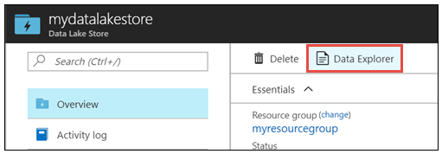

* Data Lake Store Account -> Data Explorer -> New Folder

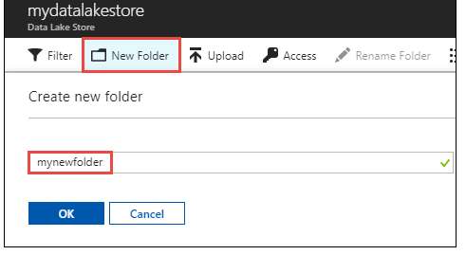

* Nested folders can be created up to any level.

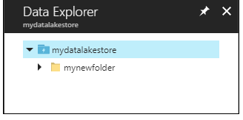

* Click Delete in the blade to delete the folders from the account.
* Data Explore ->Upload

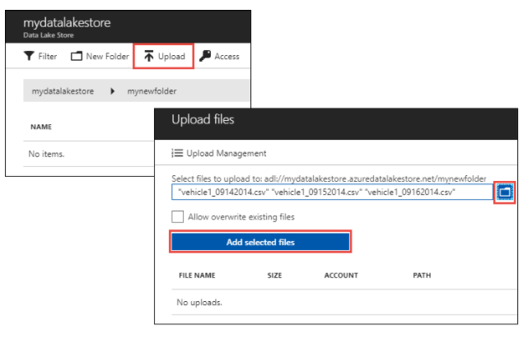

* In the Upload files blade, navigate to the files user want to upload, and then click Add selected files. User can also select more than one file to upload.